


Anguilla Maritime Administration
& Shipping Registry

AMASR

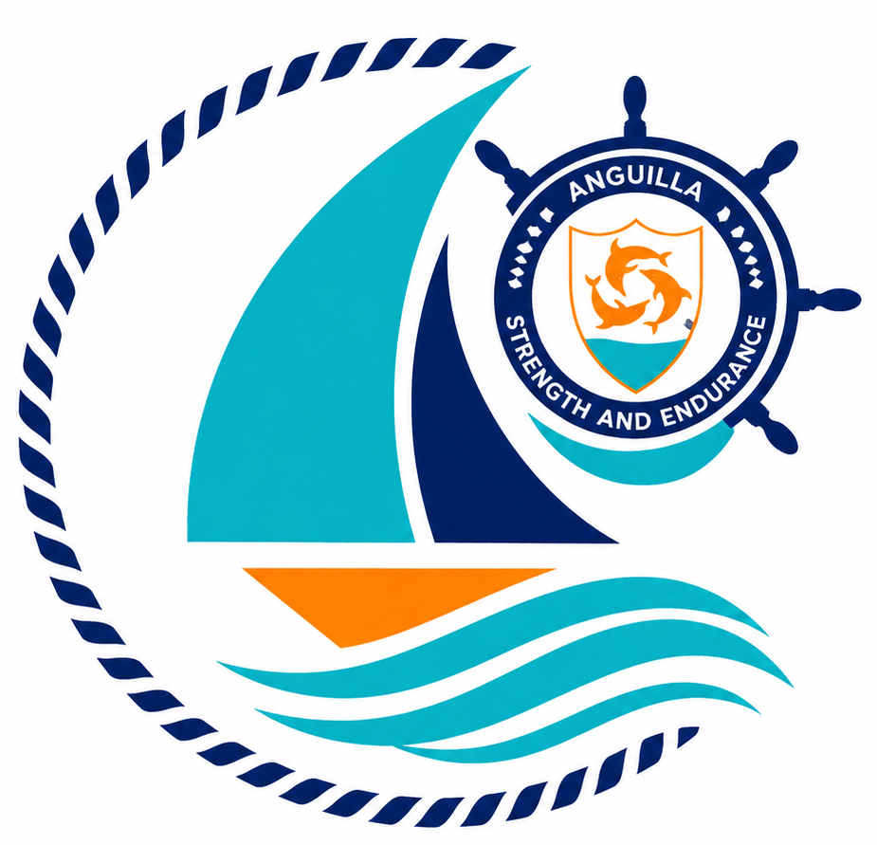

Form: | Application for Deletion
No.: | 05
Rev.: | 00
Date: | 2026-06-10
To: | Recognized Organizations, Shipowners, Managers, Masters, Seafarers, Partners, Brokers, Surveyors, and the general public.

Strength and Endurance

Address: Anguilla Maritime Administration
Anguilla, Leeward Islands, Ministry of Infrastructure, Communications, Utilities and Housing, Coronation Avenue, The Valley Anguilla
Tel: +447454760022| Email: info@amasr.ai

FORM 05 - APPLICATION FOR DELETION
Please complete this form in its entirety, electronically or in block capitals.

1. Ownership details
a) If the vessel is owned by a company
Name of the owning company
Name of demise charterer (if applicable)
Registered address
Country of incorporation |  | VAT/Registration n.
Contact person
Telephone n. |  | Email
IMO Number
b) If the vessel is owned by an individual
Name of the owner
Name of demise charterer (if applicable)
Permanent address
Nationality |  | Passport or ID n.
Telephone n. |  | Email
Confirmation of ownership structure:

- No changes – I hereby confirm that no changes have occurred in the ownership structure since the last due diligence review. A valid UBO passport is maintained on file.

- Changes occurred – Changes have been made to the ownership structure. Kindly submit the current company register extract and valid passport copies evidencing these changes.
2. Vessel Details
Vessel name
Port of registry
Official number
IMO number or HIN as applicable

3. Reason for deletion from the register
Vessel sold |  |  |  | Vessel destroyed/scrapped/lost:
Change of flag |  |  |  | End of demise charter agreement
Other to be evaluated by the Administration (please specify):
The resident agent has been notified:
Yes | No |  |  | n/a
Name of San Marino
Resident Agent
4. Declaration¹
I, the undersigned, declare under my own responsibility that I have not made any false or misleading statements in this form, being aware that anyone who makes false or misleading statements is punishable under the Criminal Code of the Anguilla.

I, the undersigned, further declare and confirm that all fees relating to the present registration application, as well as any current charges, have been duly paid in accordance with the applicable fee schedule of the Maritime Registry of the Anguilla.
All owners must sign this application
Full name(s) of Owner(s) |  | Signature(s) |  |  | Role | Date

Note: Refer also to the guidance notes overleaf.

1 Power of attorney to be attached where applicable.

- This application must be signed by the vessel owner or company director, or by an authorised representative holding a power of attorney.
- If the vessel is owned by more than one individual or company, please indicate the full names and addresses of all sharing ownership of the vessel, using a separate sheet to be attached to this form if needed.
- This application must be accompanied by the following supporting documents, as applicable:

  - if the registered owner of the vessel is a company, the applicant must provide the latest list of company directors and shareholders, issued by a competent authority (company register extract) or certified by a notary.
  - if the vessel is owned by an individual, please provide a copy of the owner’s valid passport or national ID card.
  - Where a Power of Attorney (POA) is submitted, it must clearly specify the powers granted to the attorney, include the vessel’s official number, vessel name, and IMO or HIN number. The POA must be dated prior to the date of the submitted form 05.

- If an instrument agreement is registered against the vessel, the vessel cannot be removed from the San Marino Register until an application for discharge or transfer of the registered instrument agreement has been submitted by the applicant to Anguilla.

